**Practical 6:** **Implement virtualization using VMWare ESXi Server and managing with vCenter**.

Step-1 : click on file and select new virtual machine.

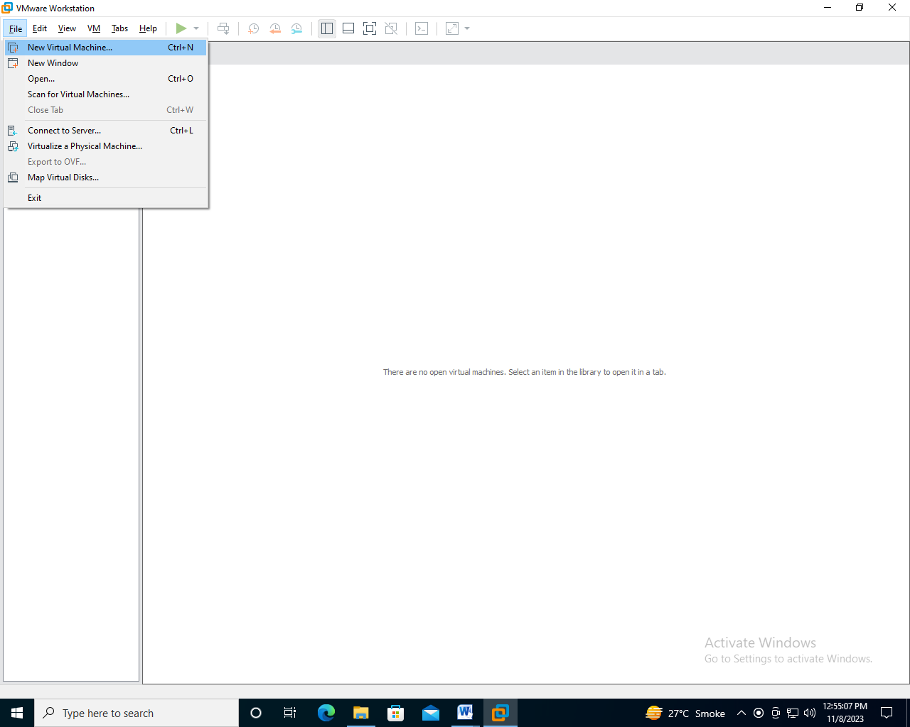

Step-2: Select custom and click on next

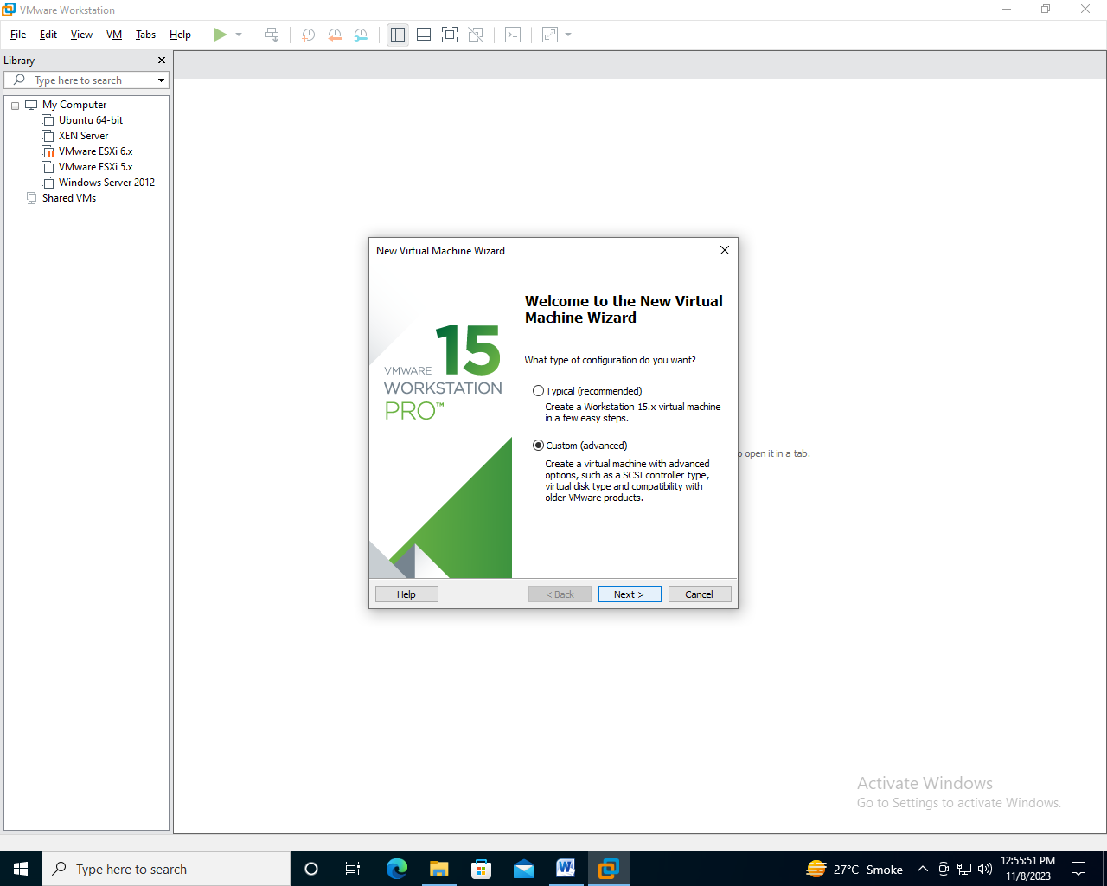

Step-3 : select workstation 15.x and click on next

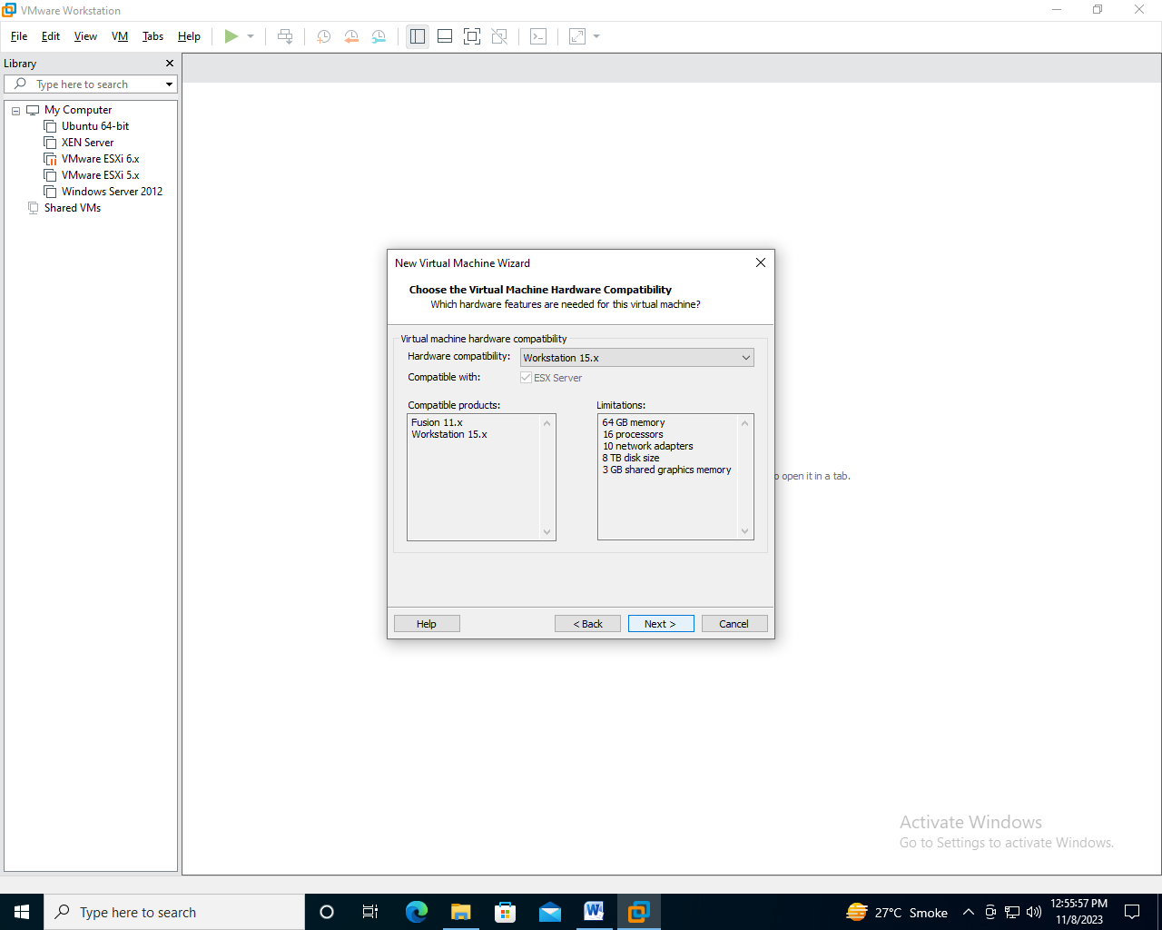

Step-4 : select install OS later and click on next

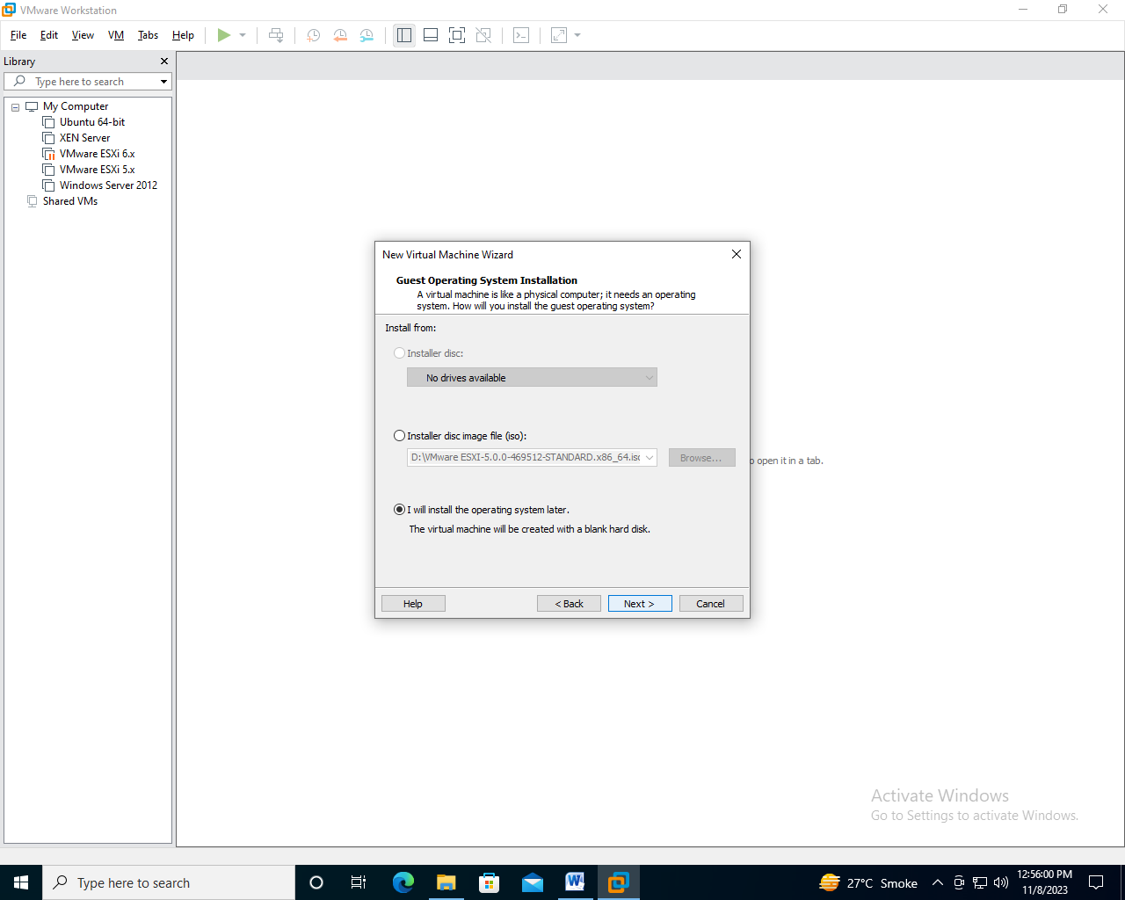

Step-5 : select VMware ESX option and version as VMware ESXI 5.x and click on next

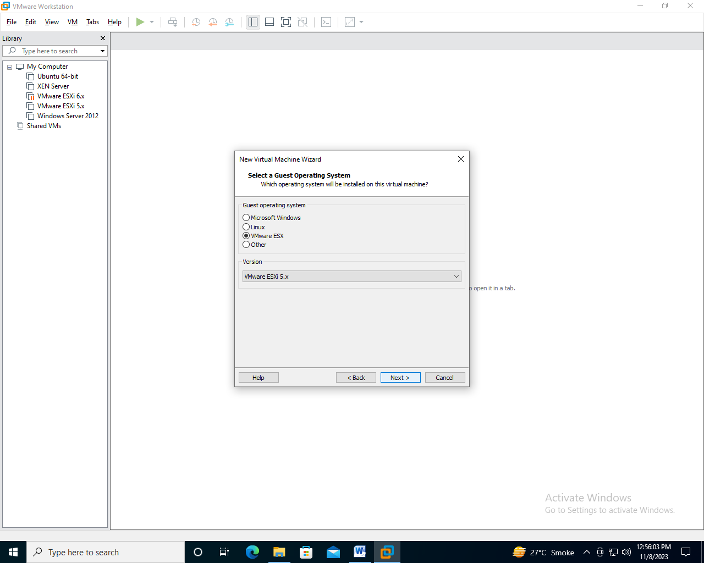

Step-6 : create a folder as esxi and select that folder in location and click on next

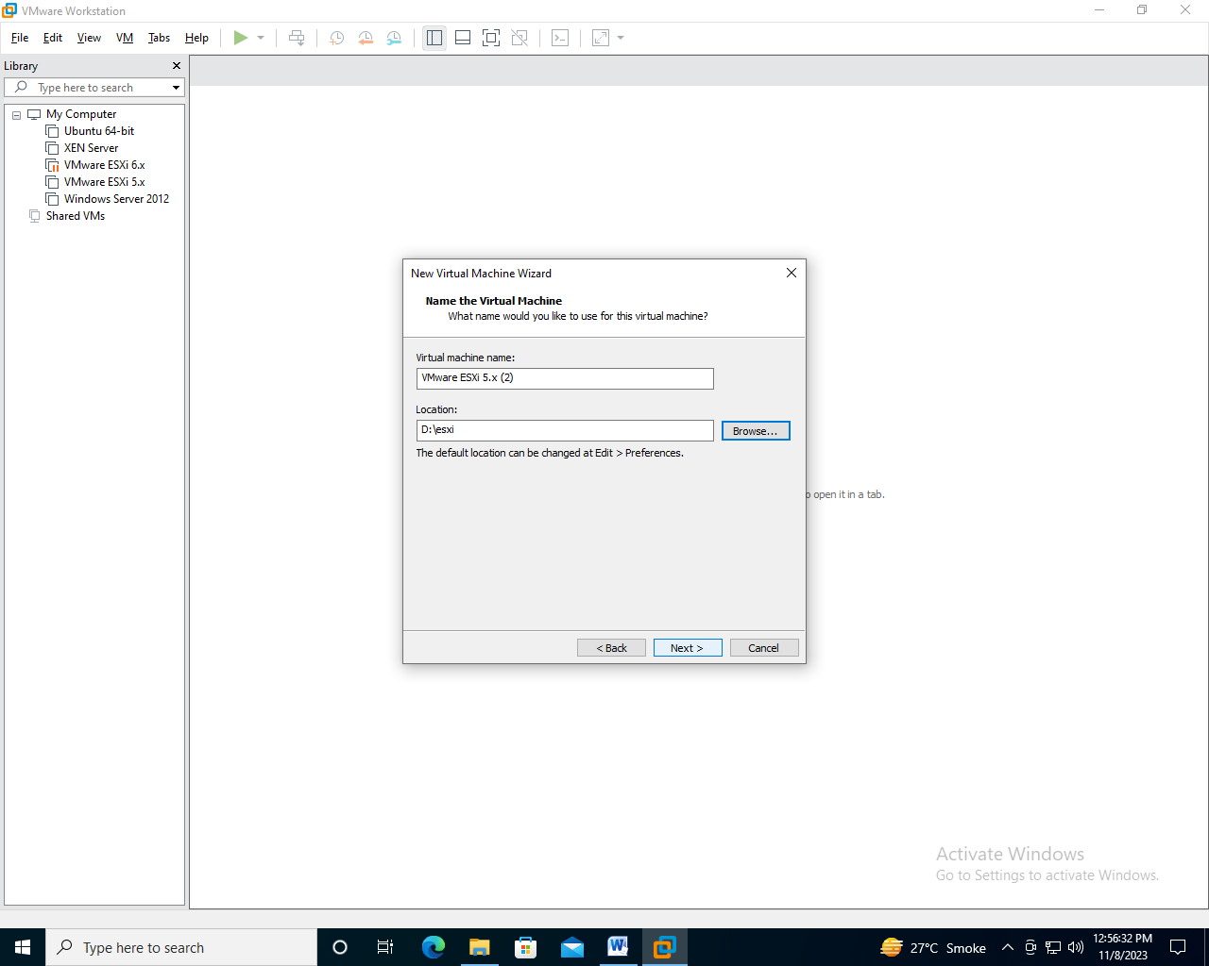

Step-7 : Assign Number of processors as 2 and Number of cores per processors as 2 and click on next

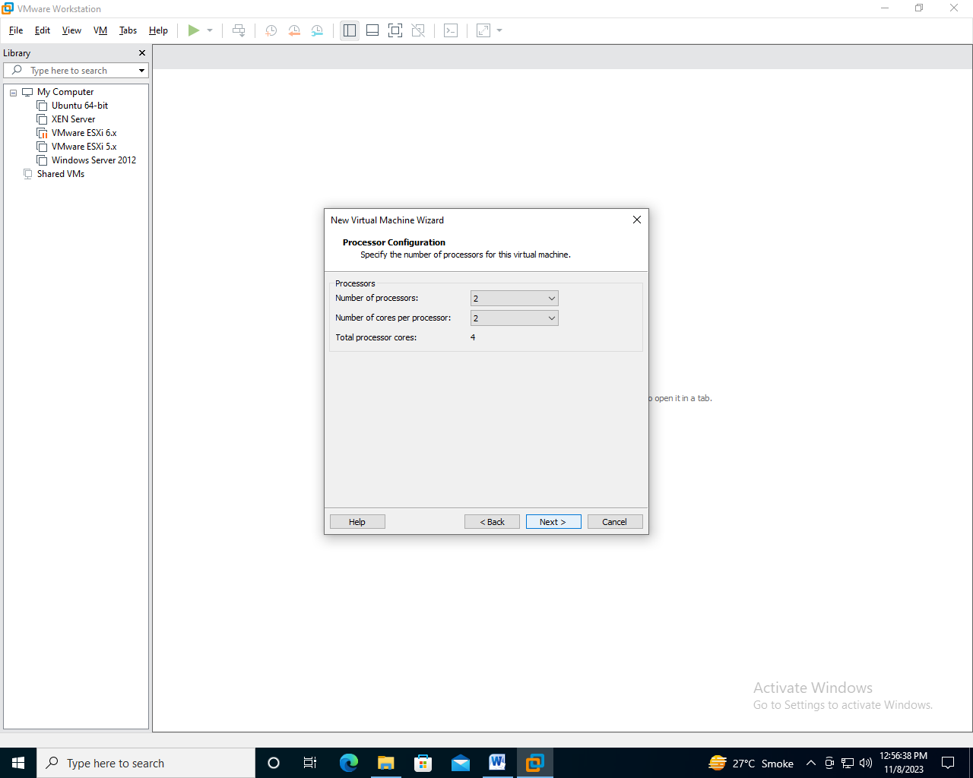

Step-8 : Assign Memory of 4GB and click on next

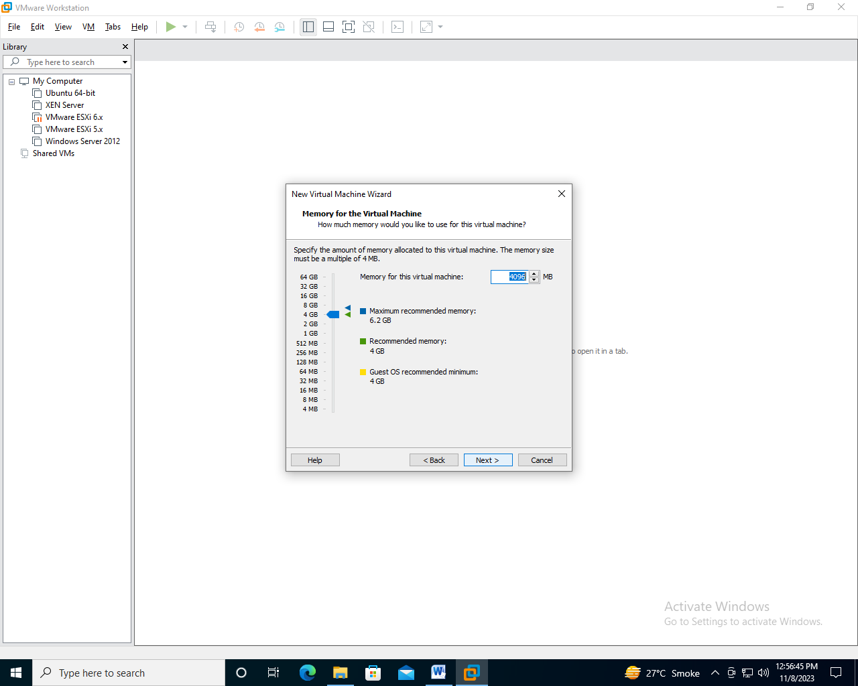

Step-9 : Select Network connection as NAT and click on next

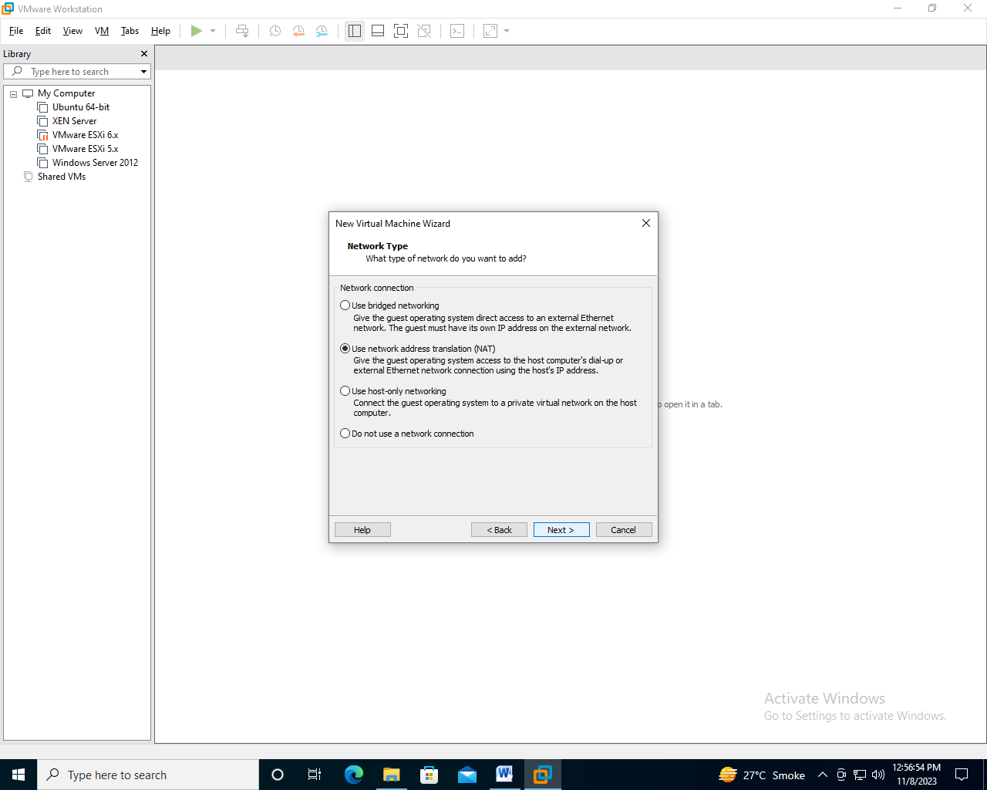

Step-10 : Select SCSI Controller as LSI Logic and click on next

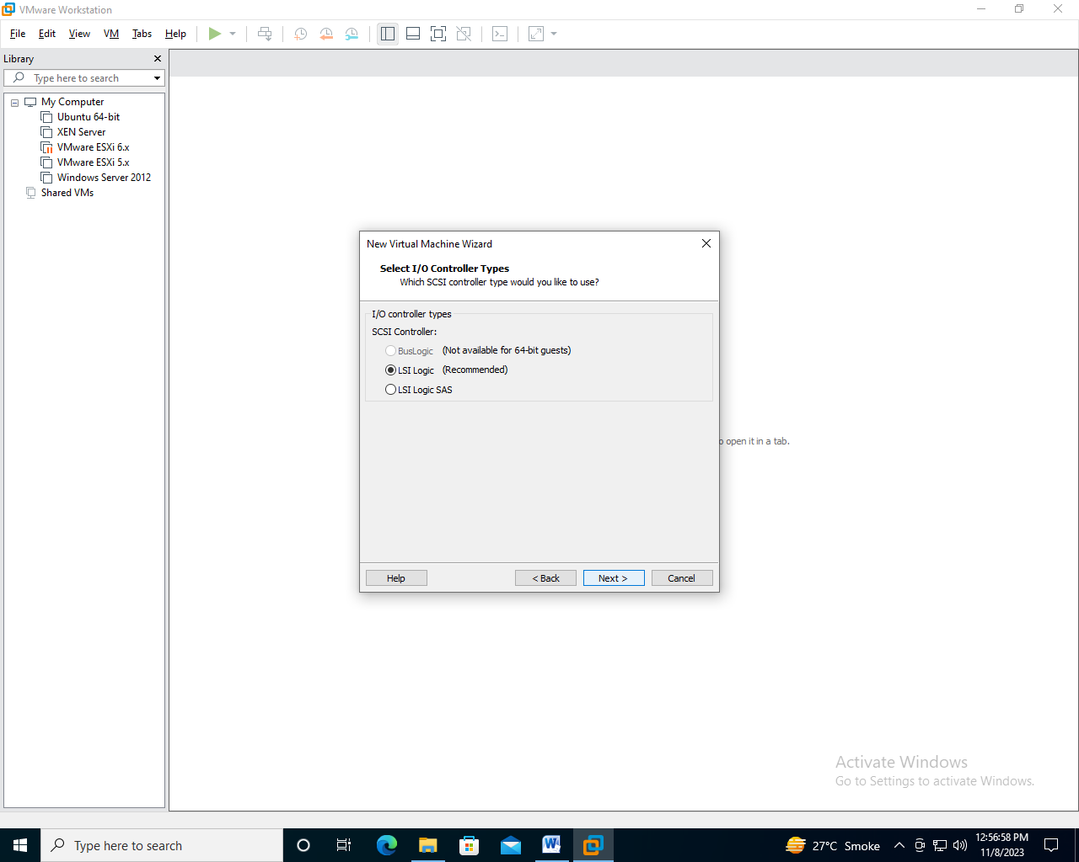

Step-11 : Select Virtual Disk Type as SCSI and click on next

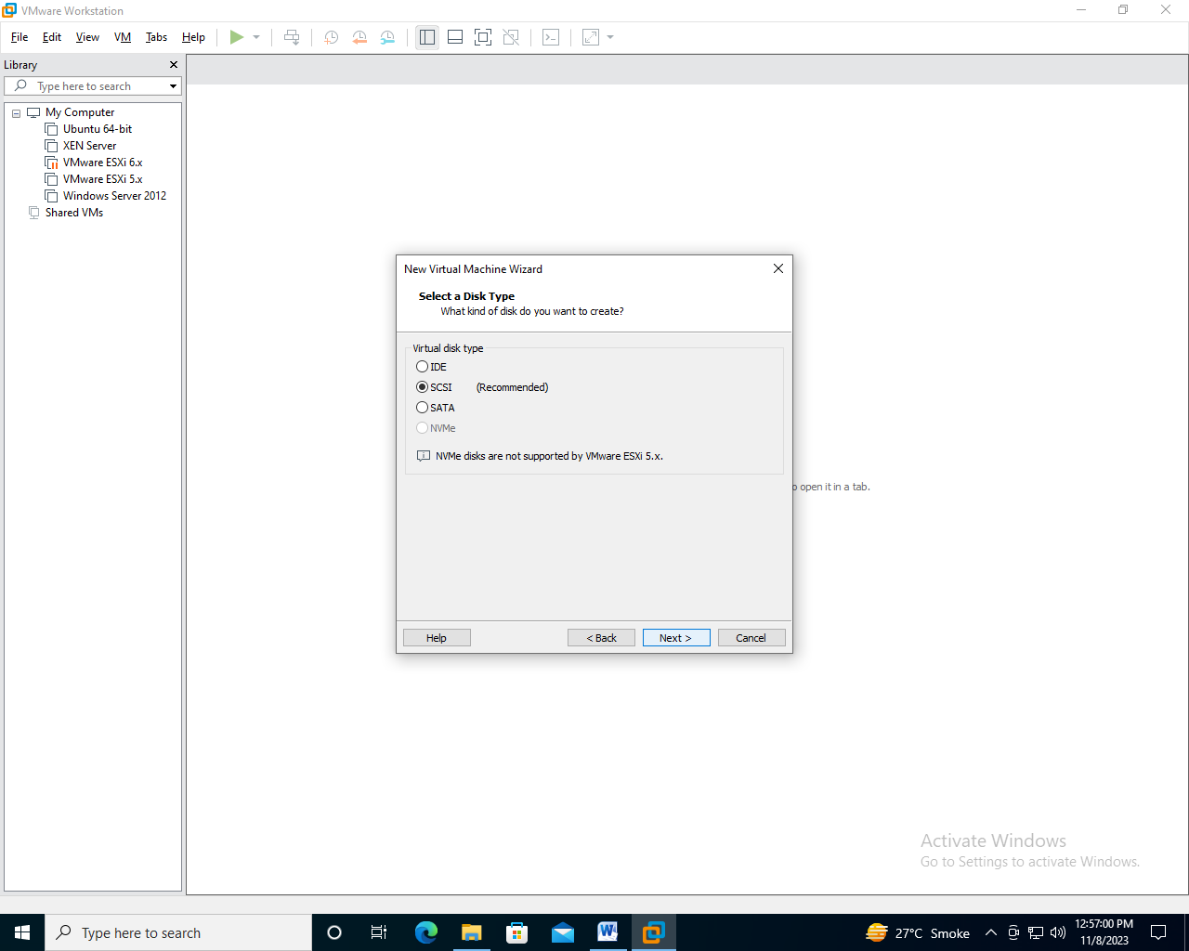

Step-12: Select Disk As Create a new virtual disk and click on next

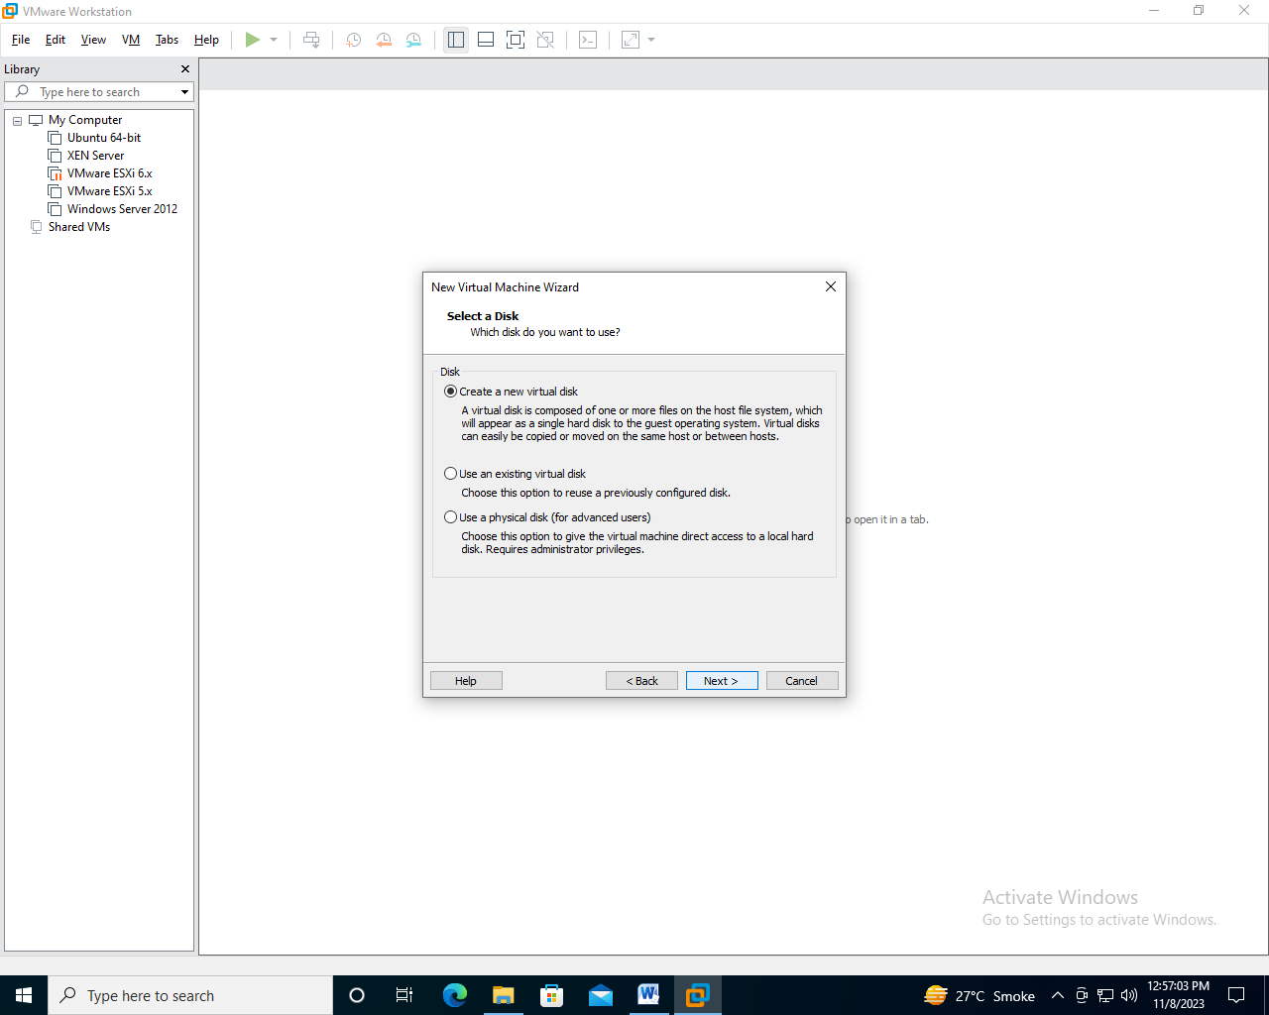

Step-13 : Assign Disk size as 50GB and click on next

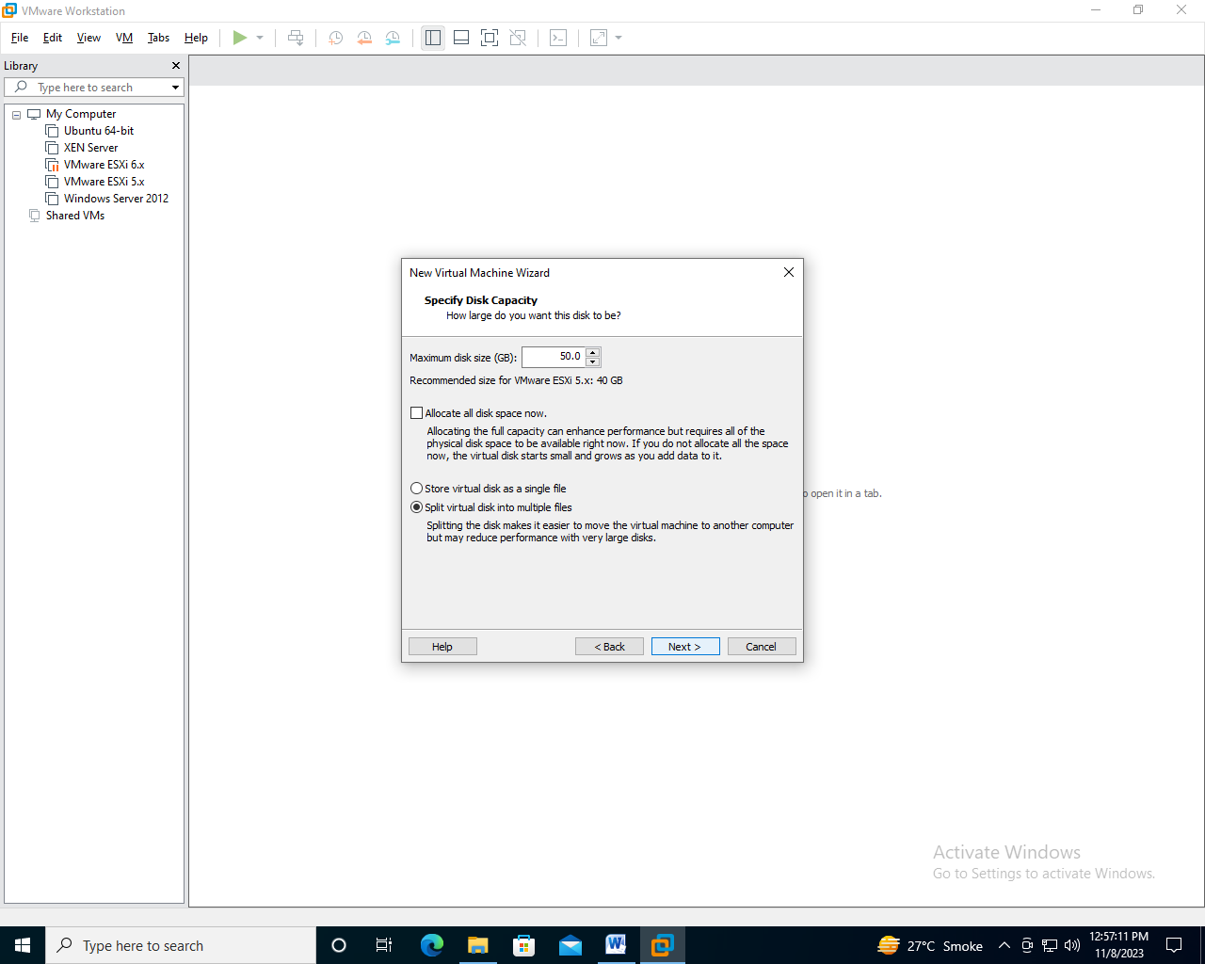

Step-14: Let file name be recommended and Click on next

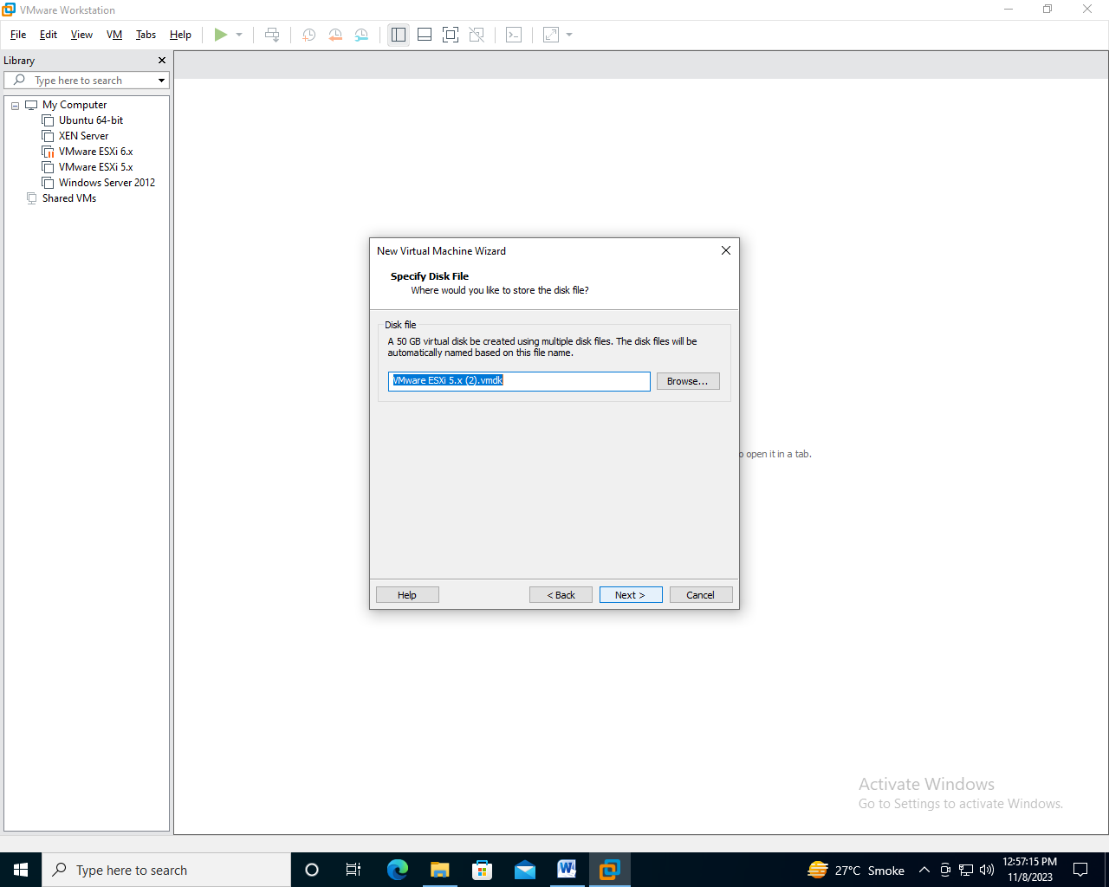

Step-15 : check the overview of the hardware selected and click on next

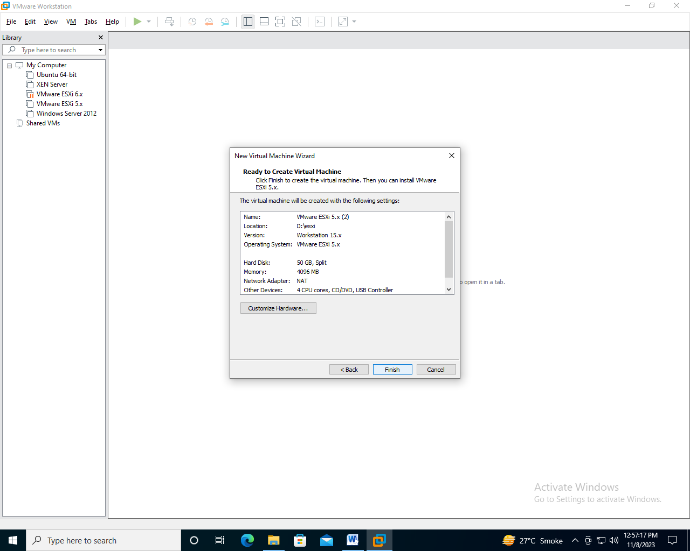

Step-16 : Click on CD/DVD (In Connection Select ISO Image File option and click on browse.)

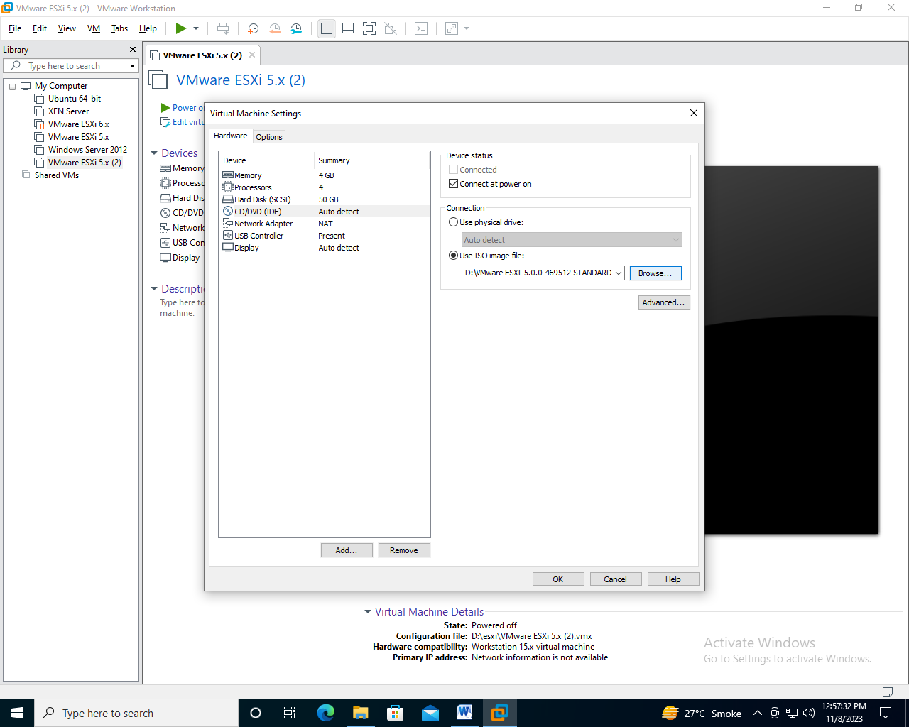

Step-17 : Select The VMware ESXI ISO file From Your Computer and click on open.

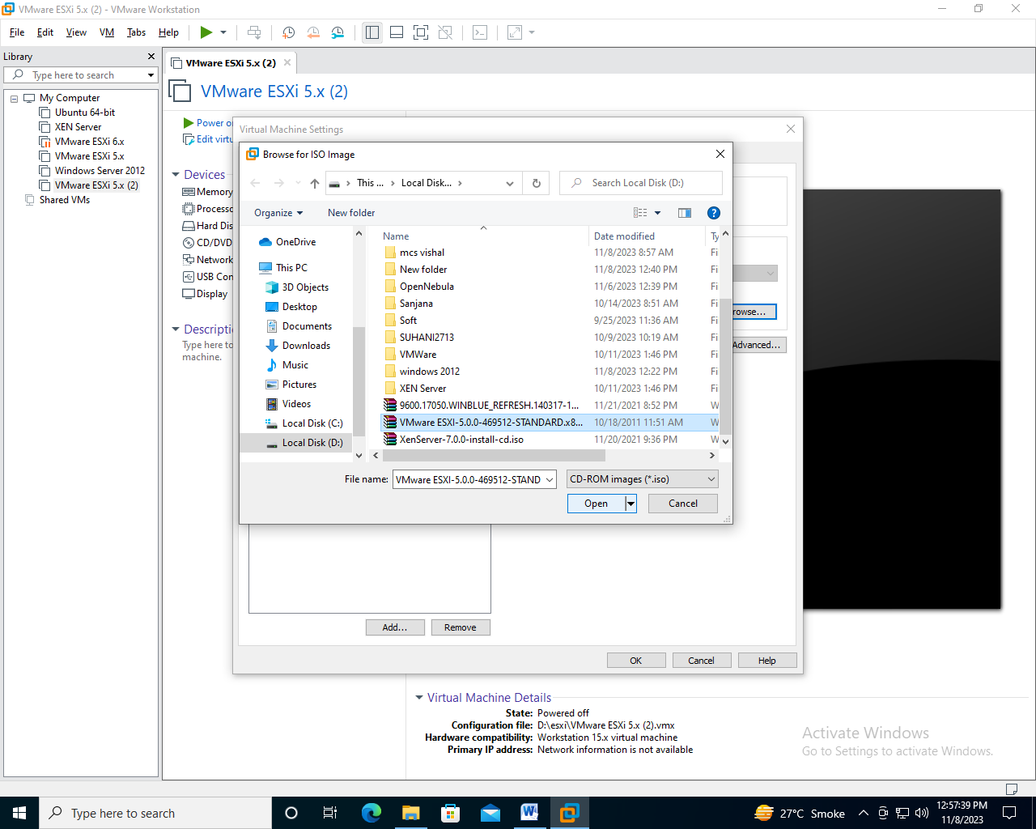

Step-18 : Click on processor And Select virtual Intel VT-x/EPT Option and click on OK.

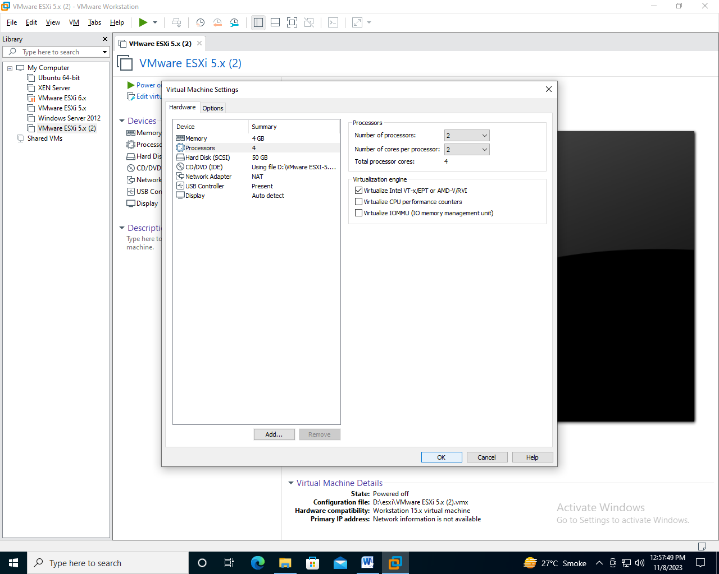

Step-19 : Now Power On the Virtual machine.

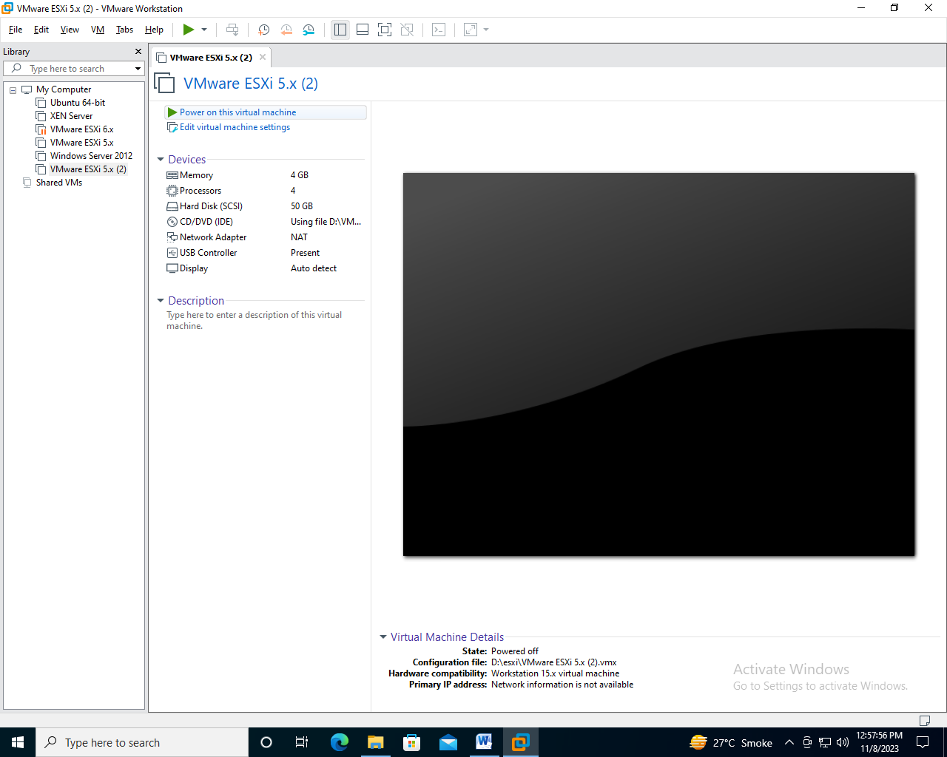

Step-20 : Wait till it automatically boots.

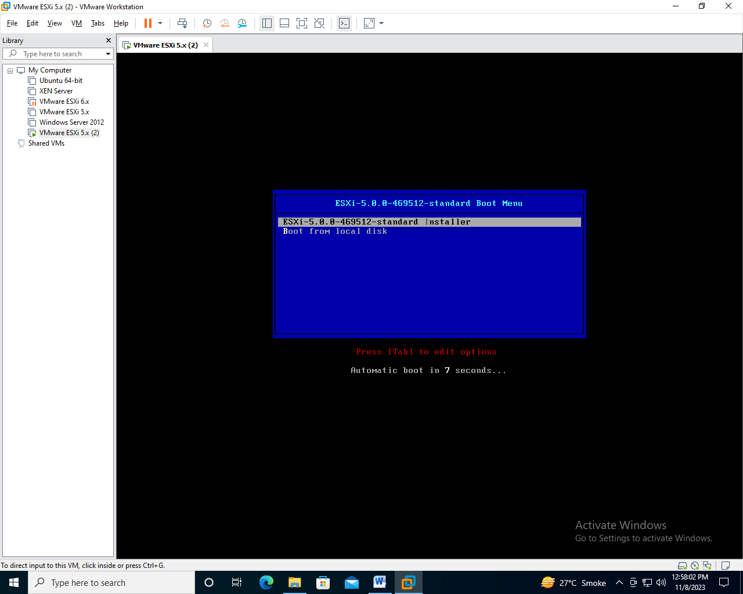

Step-21 : wait for loading

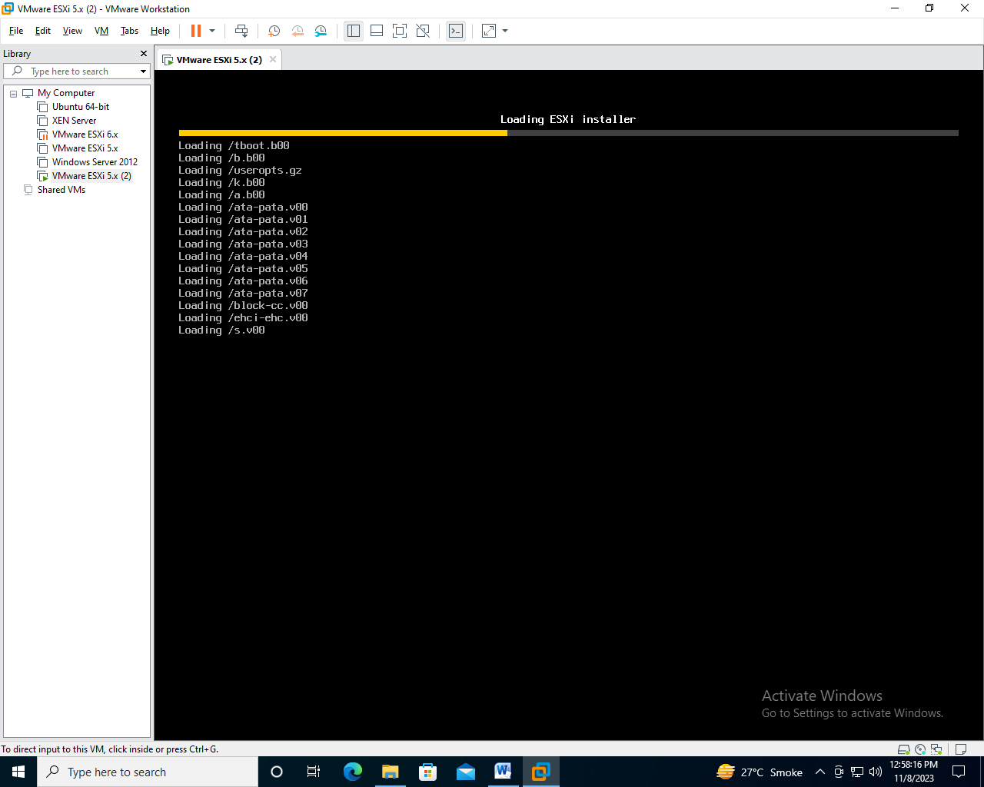

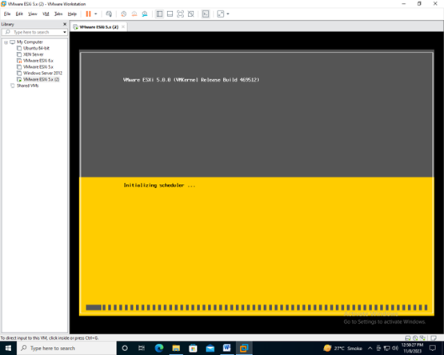

Step-22 : Press Enter Key to continue the installation.

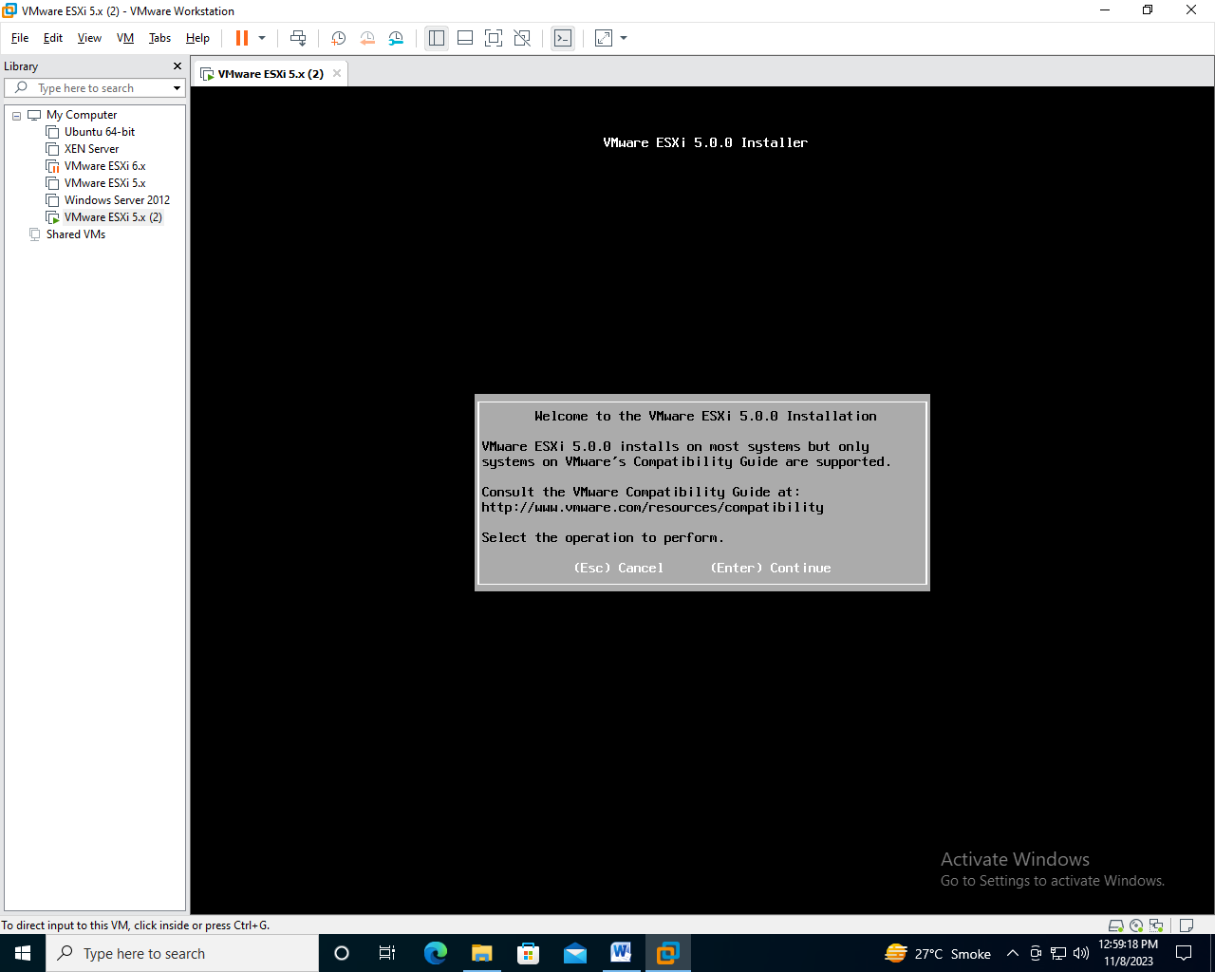

Step-23: Press F11 to Accept and Continue

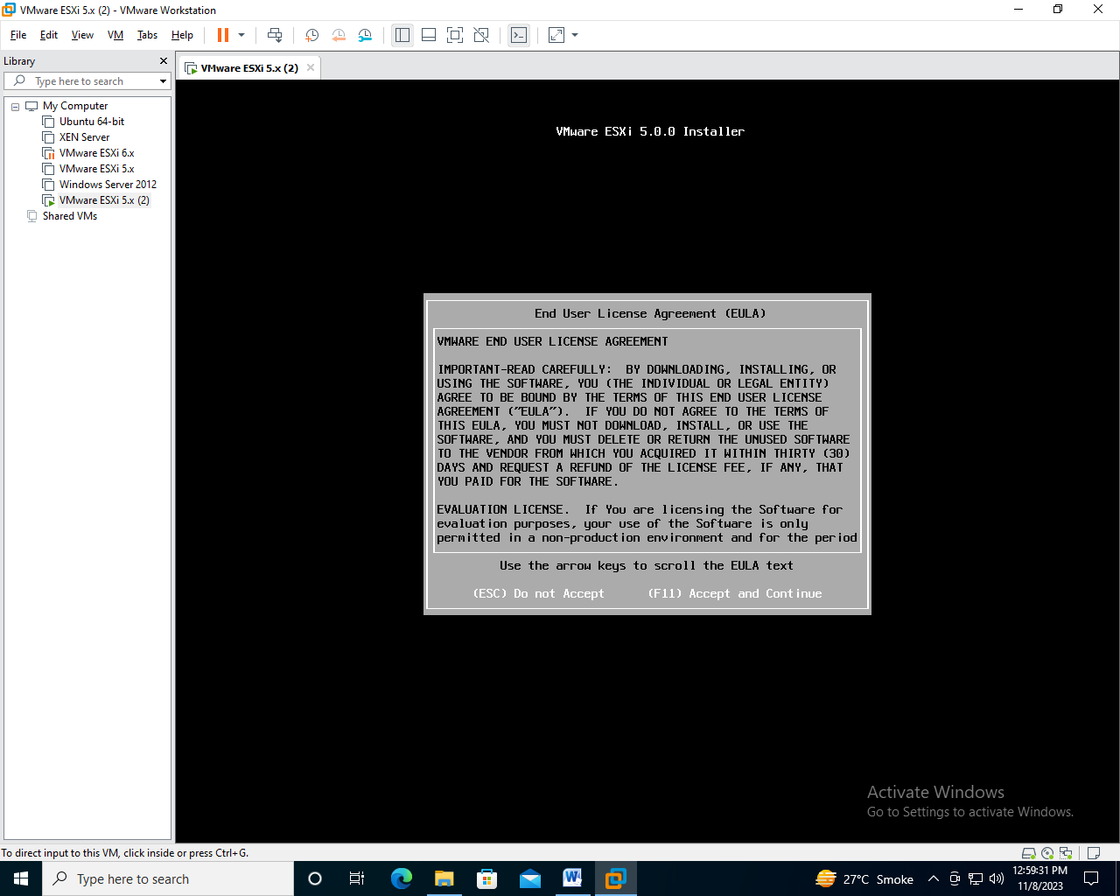

Step-24: Wait for Scanning

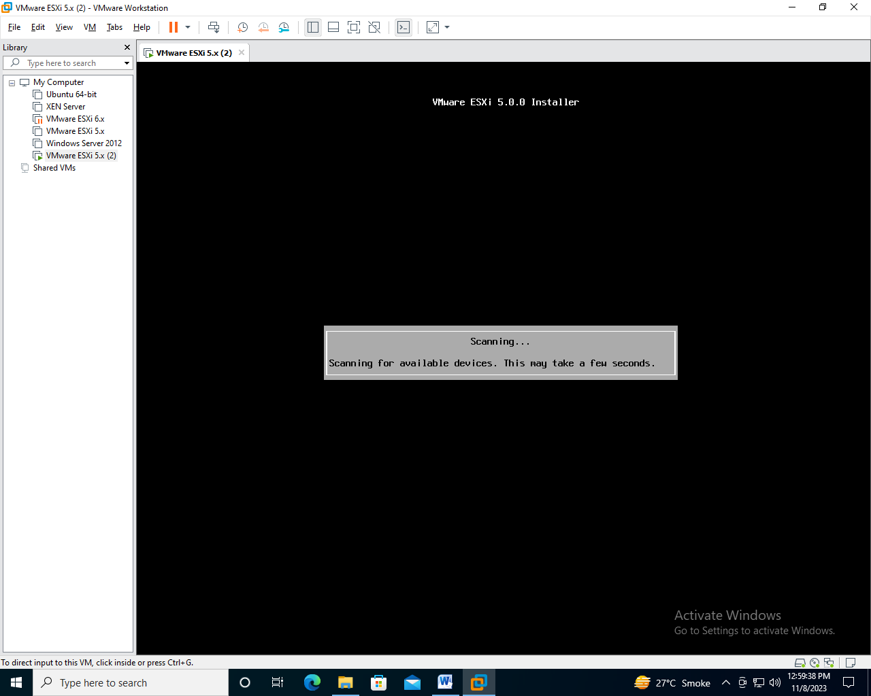

Step-25: Press Enter to continue

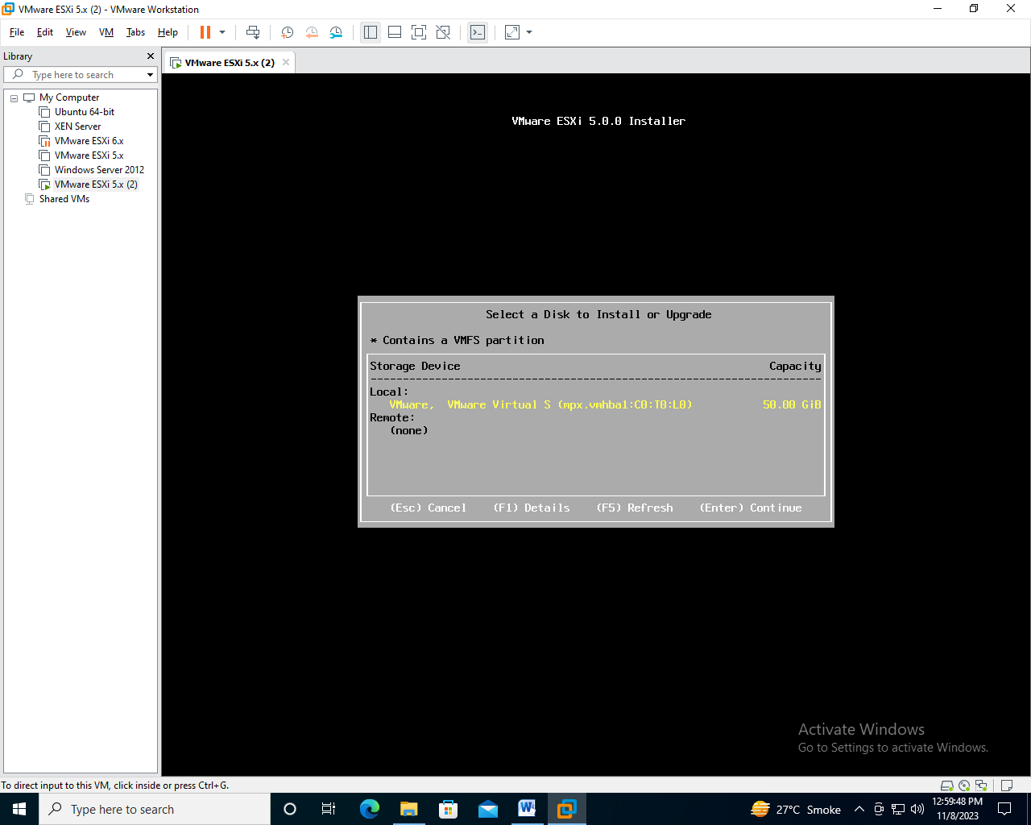

Step-26 : Select US Default and Press Enter

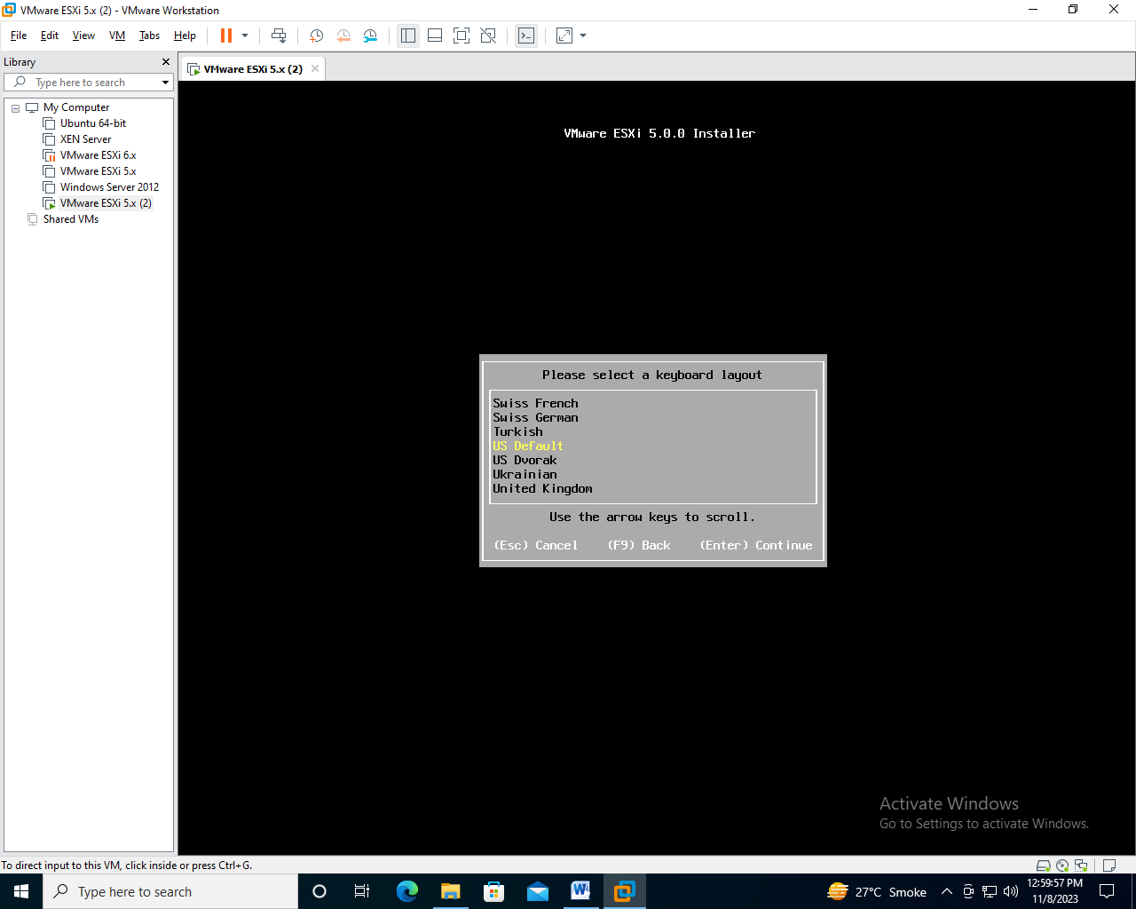

Step-27 : Give Root password and press Enter

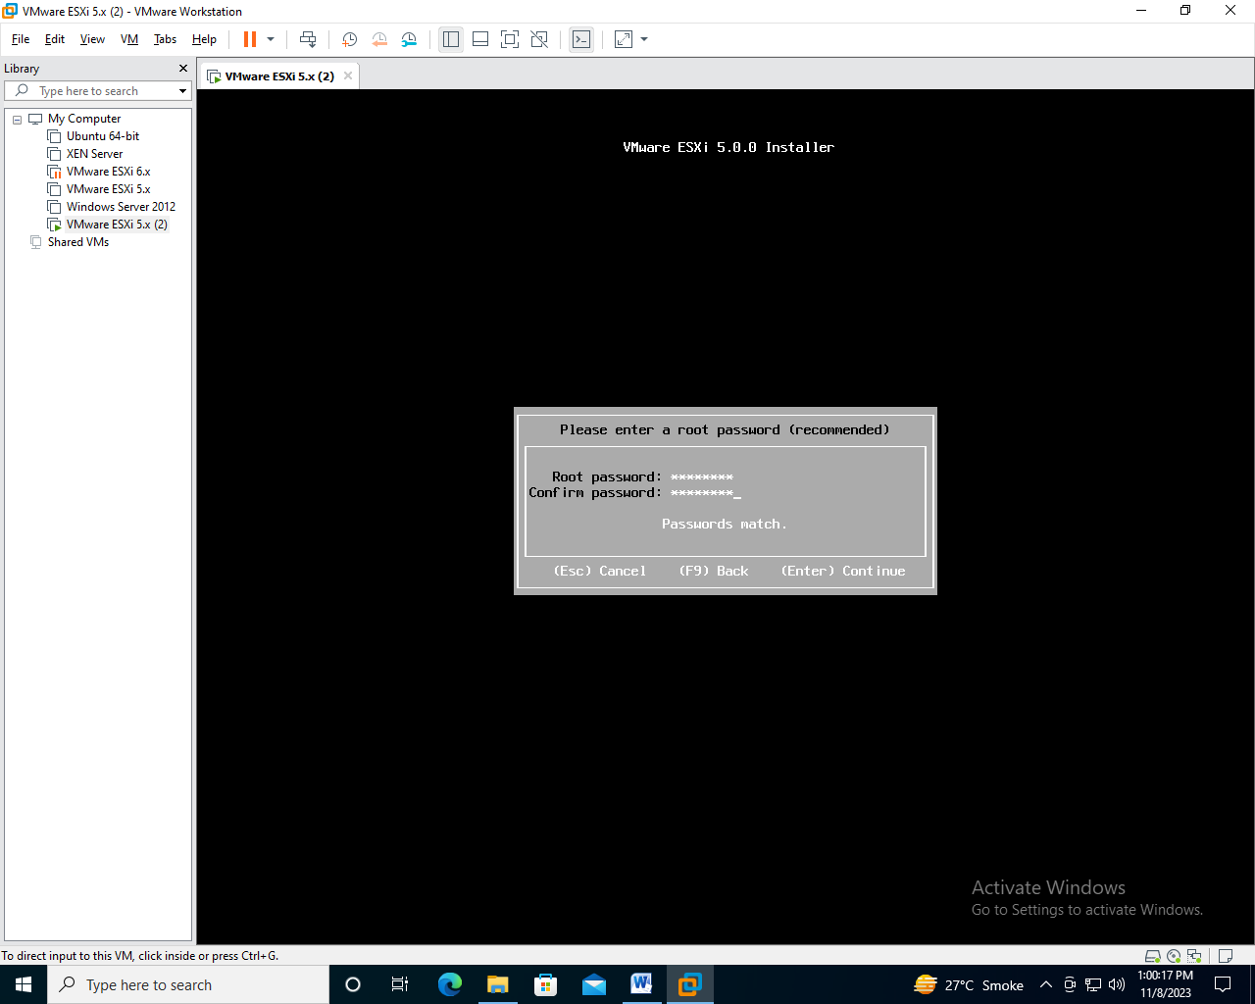

Step-28 : Wait for Scanning

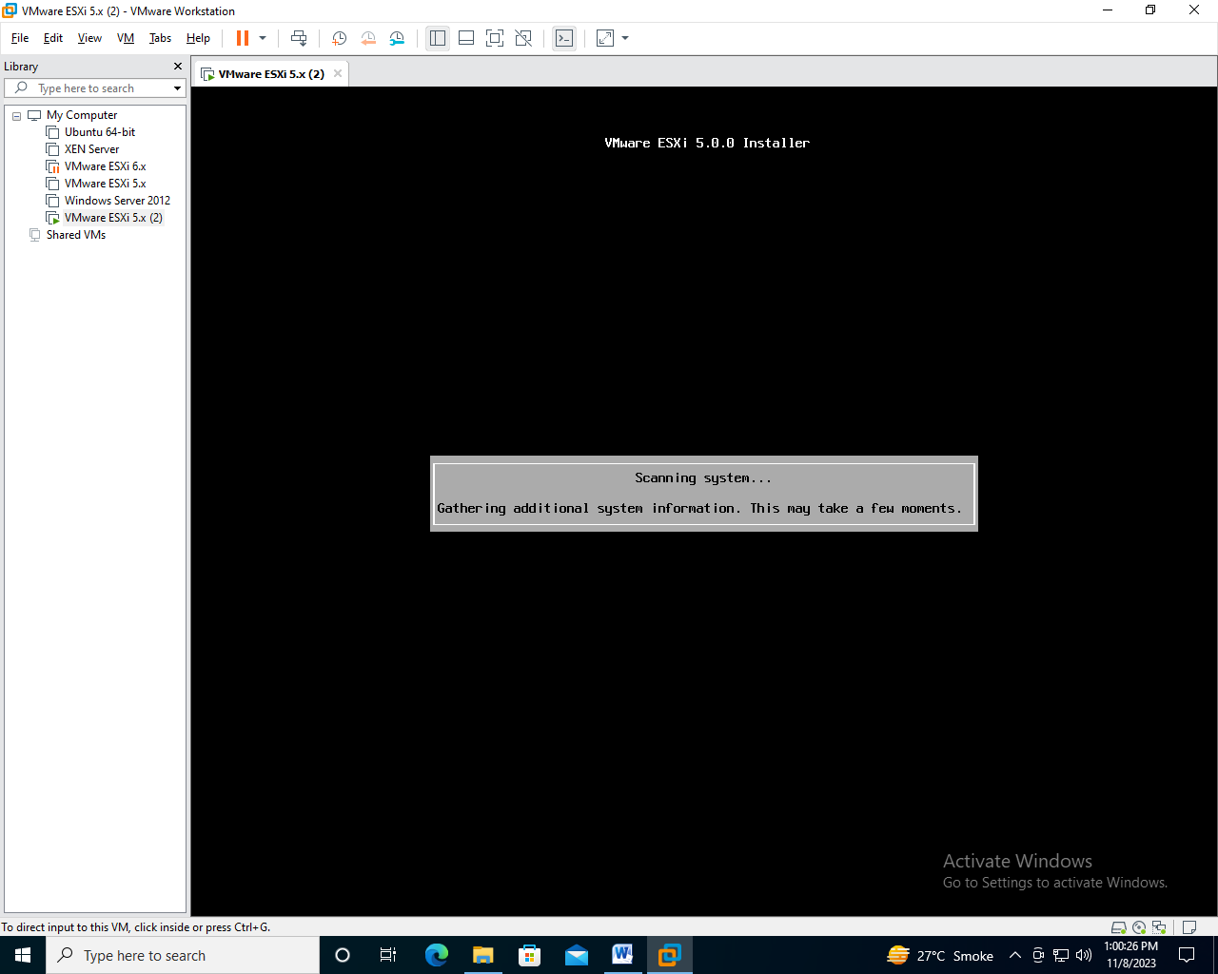

Step-29 : Press F11 to Install

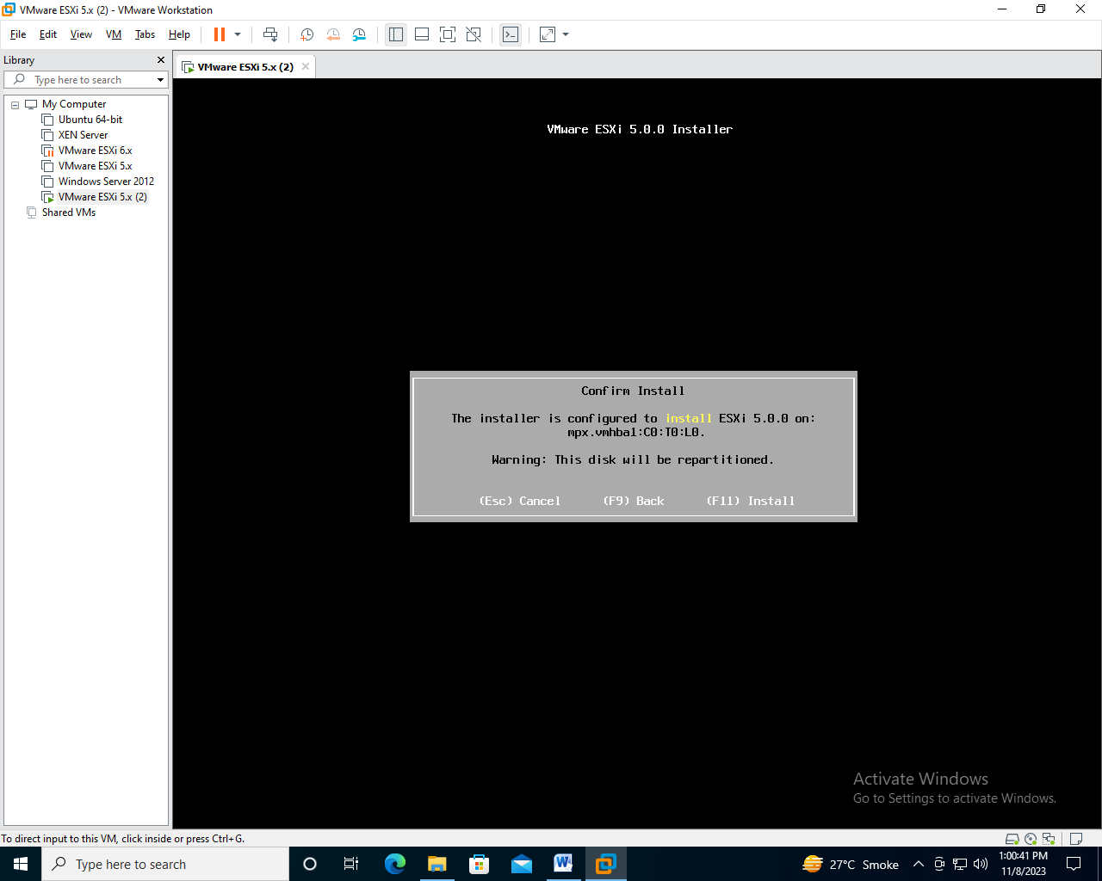

Step-30: Wait For Installation

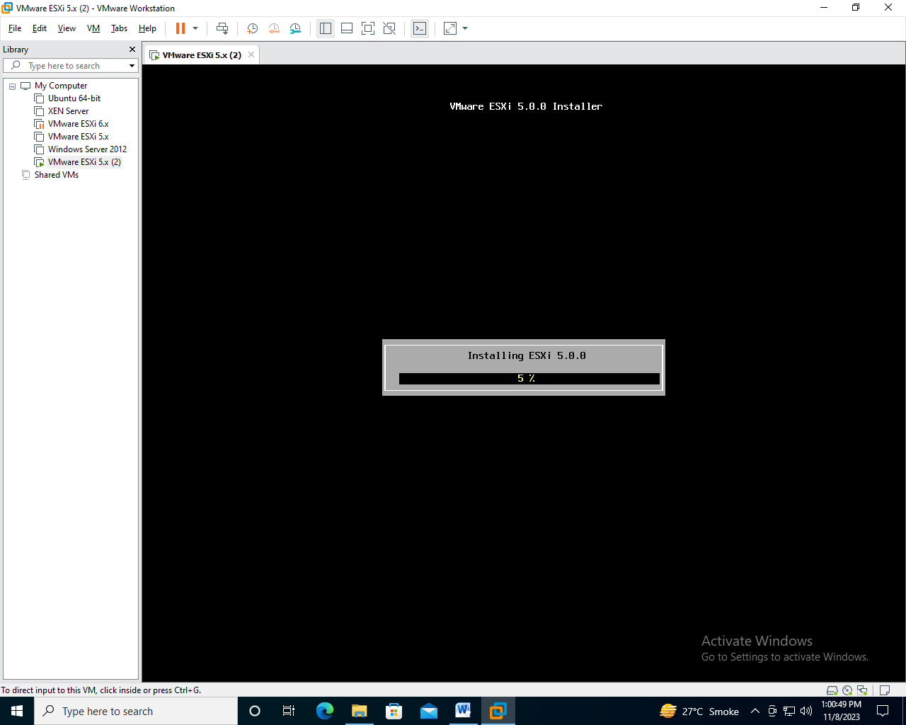

Step-31 : Press Enter To Reboot

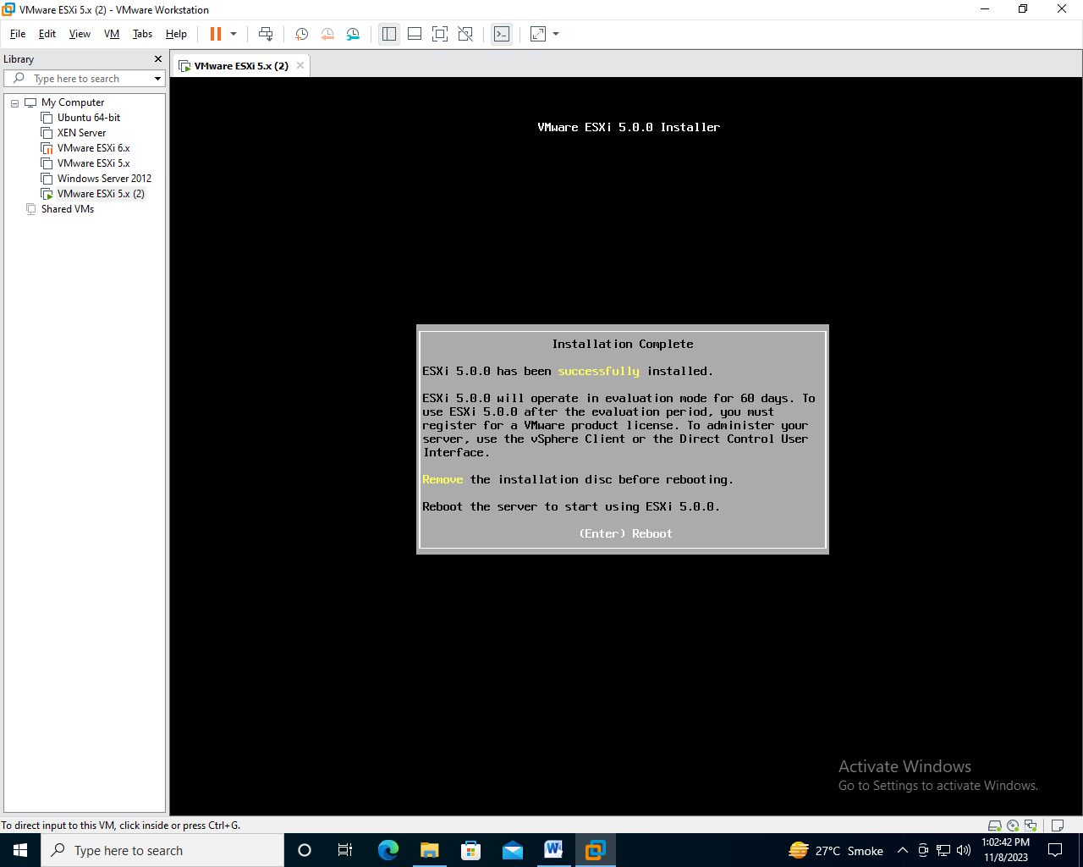

Step-32 : Wait till Process take Some time.

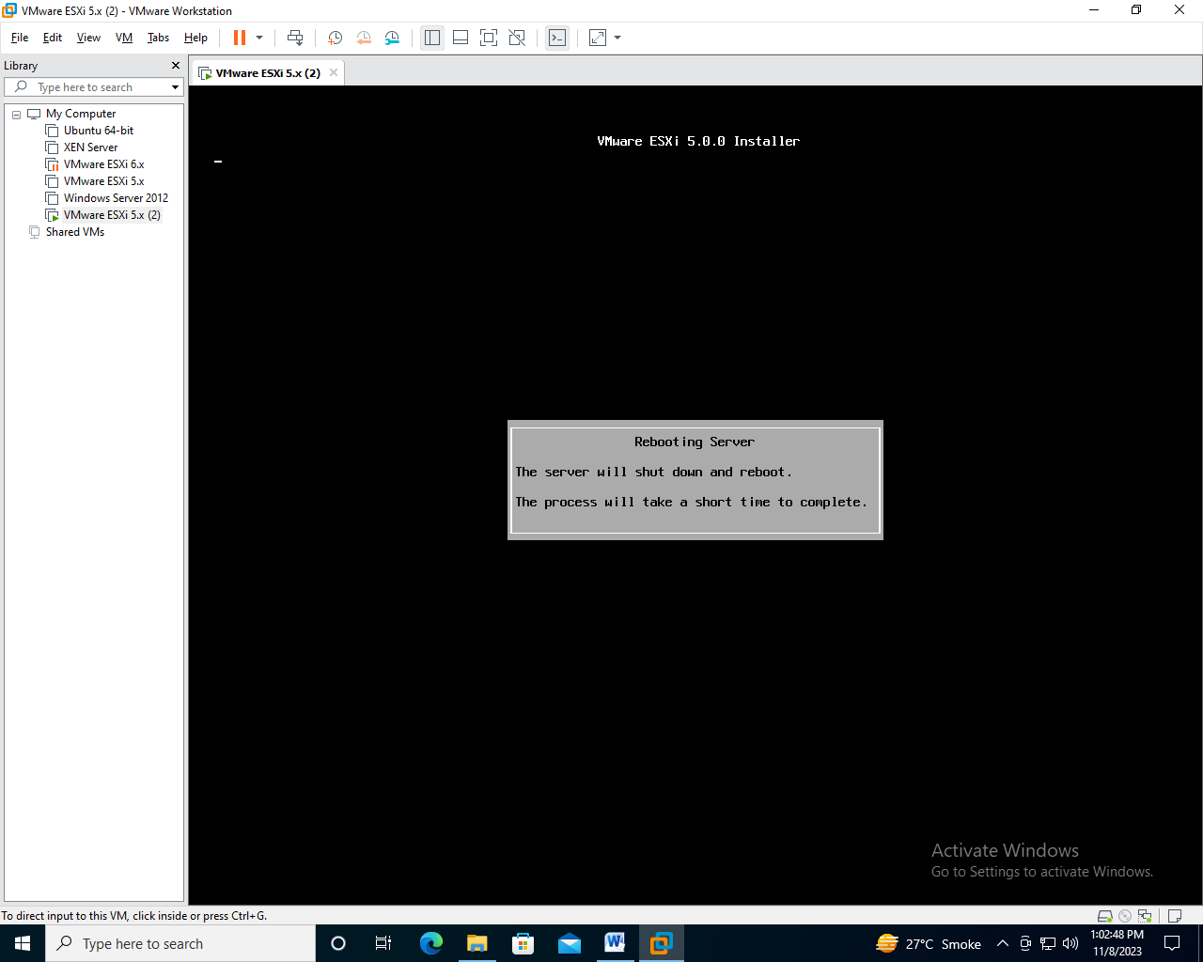

Step-33 : ESXI is Installed

